STUDENT RISK ANALYZER USING MACHINE LEARNING
Submitted By:
Aadhya Rohatgi
Section G
Registration No: 2430010485
Data Science – 4th Semester

1. Introduction (Expanded)
In the modern era, data plays a crucial role in decision-making across various domains, including education. Educational institutions generate large amounts of data related to student performance, attendance, and behavior. Analyzing this data can help in identifying patterns and predicting outcomes.
One of the major challenges faced by educational institutions is identifying students who are at risk of poor academic performance or failure. Early identification of such students allows institutions to take preventive measures such as additional guidance, counseling, or academic support.
Machine Learning (ML), a subset of Artificial Intelligence, provides powerful techniques to analyze data and build predictive models. These models can learn patterns from historical data and make predictions about future outcomes.
In this project, a machine learning-based system called Student Risk Analyzer is developed. The system predicts whether a student is at academic risk based on multiple factors such as study habits, family background, and past performance.

2. Problem Statement (Detailed)
The main objective of this project is:
To build a machine learning model that predicts whether a student is at academic risk (fail) or safe (pass).
This problem can be categorized as a binary classification problem, where:
- Output = 1 → Student is at risk
- Output = 0 → Student is safe
The challenge lies in accurately identifying at-risk students while minimizing incorrect predictions.

3. Dataset Description (Detailed)
The dataset used in this project contains information about students’ academic and personal attributes.
Features in the Dataset:
- Academic Features:
  - G1, G2, G3 (grades)
  - Study time
  - Failures
- Behavioral Features:
  - Absences
  - Going out frequency
  - Free time
- Demographic Features:
  - Age
  - Family size
  - Parents' education
- Lifestyle Features:
  - Internet access
  - Alcohol consumption
  - Health status

Target Variable Creation
The dataset originally contains continuous marks (G3). To convert it into a classification problem:
- G3 < 10 → At Risk (1)
- G3 ≥ 10 → Safe (0)
This transformation helps in simplifying the prediction problem.

4. Data Preprocessing (Very Detailed)
Data preprocessing is one of the most important steps in machine learning. Raw data cannot be directly used for model training.

4.1 Handling Missing Values
The dataset was checked for missing values:
df.isnull().sum()
Result:
- No missing values were found

4.2 Encoding Categorical Variables
Machine learning models cannot process textual data. Therefore, categorical variables were converted into numerical format using One-Hot Encoding.
df = pd.get_dummies(df, drop_first=True)
Explanation:
- Each category is converted into binary (0/1)
- Avoids ordinal misinterpretation

4.3 Feature Engineering
A new column called risk was created:
df['risk'] = df['G3'].apply(lambda x: 1 if x < 10 else 0)
This converts the problem into classification.

4.4 Removing Data Leakage
Columns G1, G2, and G3 were removed:
df = df.drop(['G1','G2','G3'], axis=1)
Reason:
These columns directly represent performance and would make prediction unrealistic.

4.5 Data Scaling (Conceptual)
Although not strictly required for tree-based models, scaling helps improve model performance in some algorithms.

5. Methodology (Expanded)
The project follows a structured machine learning pipeline:
- Data Collection
- Data Cleaning
- Data Transformation
- Feature Engineering
- Model Selection
- Model Training
- Model Evaluation
- Model Comparison

6. Train-Test Split (Detailed)
The dataset was divided into training and testing sets:
train_test_split(X, y, test_size=0.2, random_state=42)
Explanation:
- Training set → used to train model
- Testing set → used to evaluate model
Using random_state=42 ensures reproducibility.

7. Logistic Regression (Detailed + Theory)
Logistic Regression is a statistical method used for binary classification.

Mathematical Model
$$P=\frac{1}{1+e^{-z}}$$
Where:
$$z=w_{1}x_{1}+w_{2}x_{2}+...+b$$

Working
- Calculates weighted sum of inputs
- Applies sigmoid function
- Outputs probability

Advantages
- Simple and interpretable
- Fast training

Limitations
- Assumes linear relationship
- Cannot capture complex patterns

8. Random Forest (Detailed)
Random Forest is an ensemble technique that combines multiple decision trees.

Working
- Random subsets of data are selected
- Multiple trees are trained
- Predictions are combined

Advantages
- Handles complex data
- Reduces overfitting
- Provides feature importance

Limitations
- Computationally expensive
- Less interpretable

9. XGBoost (Detailed)
XGBoost is an advanced boosting algorithm.

Working
- Models are trained sequentially
- Each model focuses on previous errors

Advantages
- High accuracy
- Efficient computation
- Handles imbalanced data

10. Model Evaluation (Expanded)
Metrics used:

Accuracy
Percentage of correct predictions.

Precision
How many predicted positives are correct.

Recall
How many actual positives are detected.

F1 Score
Balance between precision and recall.

11. Confusion Matrix
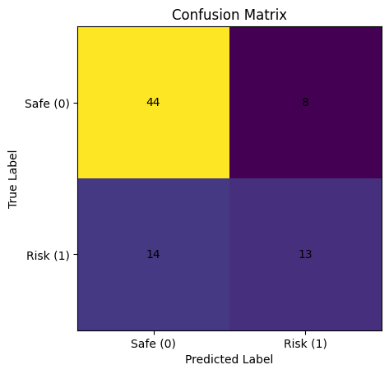
The confusion matrix represents the performance of the classification model by comparing actual and predicted values. It shows how many at-risk students were correctly identified and how many were misclassified.

Explanation
- True Positive → Correctly predicted risk
- False Negative → Missed risky students
- True Negative → Correctly predicted safe
- False Positive → Incorrect prediction

12. Feature Importance
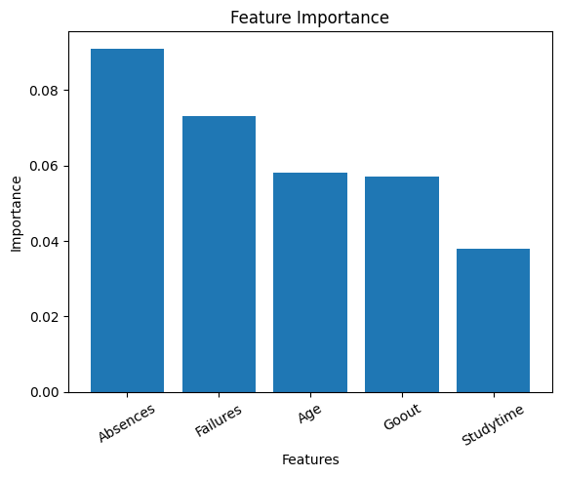
The feature importance graph highlights the most influential factors affecting student performance. Absences and failures are the most significant predictors of academic risk.

Key Observations
- Absences is the most influential feature
- Failures strongly impact performance
- Study habits affect outcomes

13. Model Comparison (Expanded)
Model | Accuracy | Recall | Observation
Logistic Regression | 73% | Low | Cannot capture complexity
Random Forest | 71% | Moderate | Better feature insights
XGBoost | 72% | High | Best for detecting risk

14. Key Insight
In real-world problems, recall is more important than accuracy when identifying critical cases.

15. Improvements Observed
- Class imbalance handling improved performance
- Ensemble methods improved predictions
- Boosting improved recall

16. Conclusion (Detailed)
This project demonstrates how machine learning can be applied in education to predict student risk.
While Logistic Regression provided good baseline accuracy, XGBoost outperformed other models in detecting at-risk students.
Thus, XGBoost is the most suitable model for this problem.

17. Future Scope (Expanded)
- Hyperparameter tuning
- Real-time implementation
- Integration with school systems
- Deep learning models

